CS564 Endsem Exam

Outputs of different models:-

Feed Forward Neural Network 1st

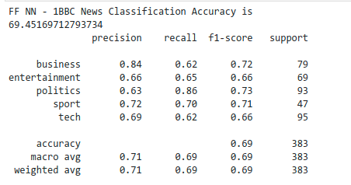

Feed Forward Neural Network (Pre-Trained) 2nd

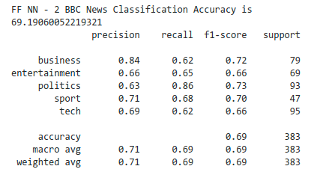

RNN

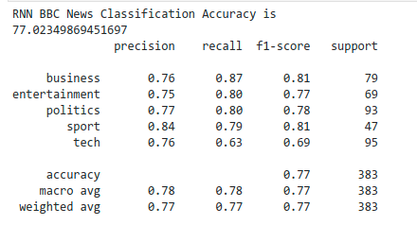

Ensemble (Max Vote)

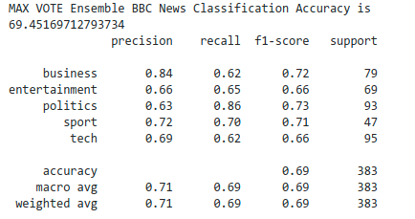

Ensemble (Weighted Vote)

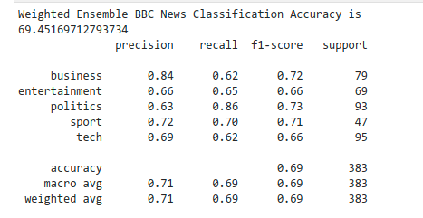

In the above results we see that our Recurrent Neural Network performs the best among the base models . In the ensemble we can see that the overall accuracy is 70% and both the max weight and the weighted ensemble perform almost the same with slight differences in the F1 scores of some individual classes.

The outputs predictions of all the models are stored as csv files in the csv_outputs directory.

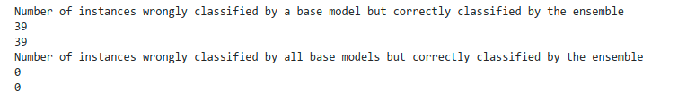

Also, we can see that there are 39 instances which were misclassified by any of the base model but were correctly classified by the ensemble models. Also, there is no such instance which is misclassified by all models which is correctly classified by our ensemble model.